

**Name : MOHAMMAD SHAIK BASHA**

**Regd no 192111459**

**Subject : csa4053-MANAGEMENT INFORMATION**

**systems with commerce**

**1)aim:- To draw the UML diagrams for HOTEL RESERVATION SYSTEM**

**DIAGRAM:-**

**USECASE:-**

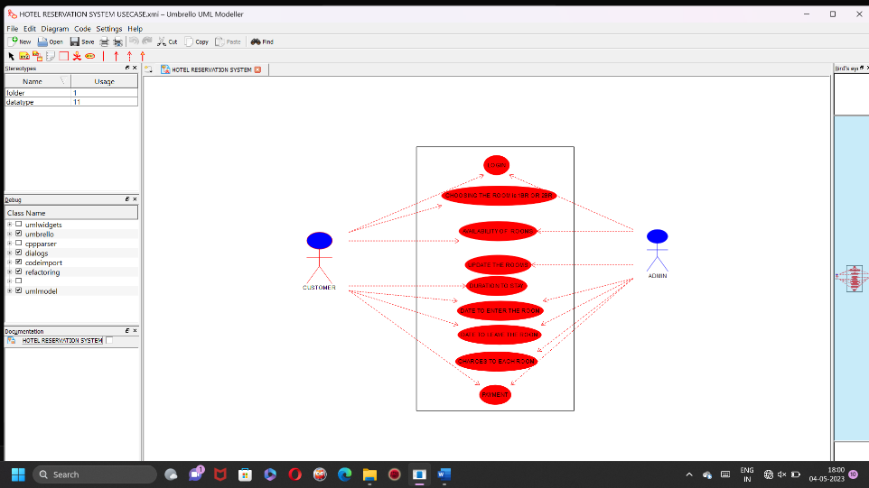

**STATE DIAGRAM:-**

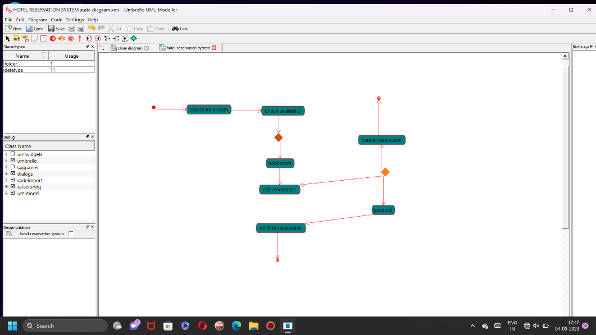

**2)aim:- To draw the USECASE diagram for COFFEE ORDERING SYSTEM….**

**DIAGRAM:-**

**USECASE:-**

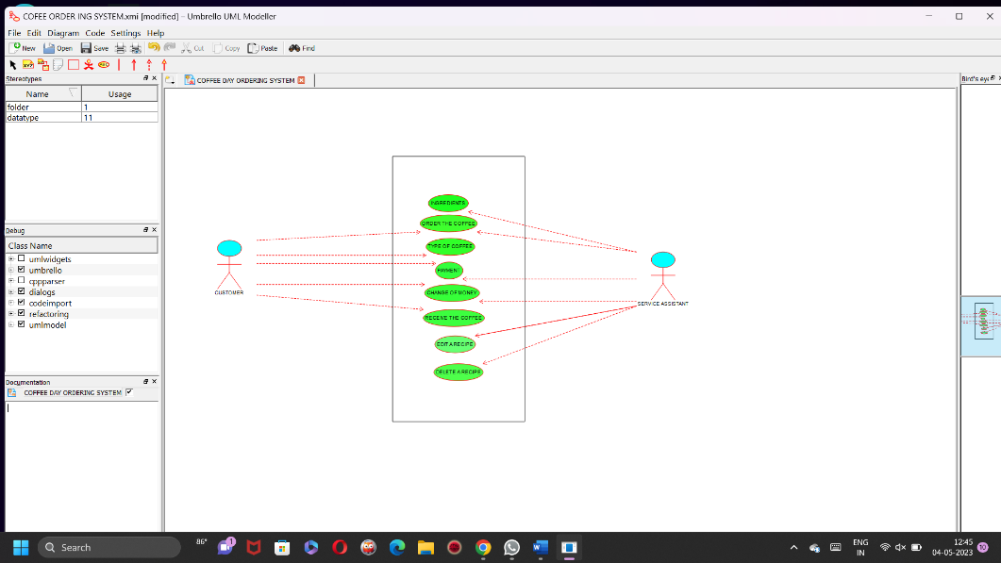

**3)aim:- To draw the CLASS diagram for ONLINE AIRLINE RESERVATION SYSTEM…**

**DIAGRAM:-**

**CLASS DIAGRAM:-**

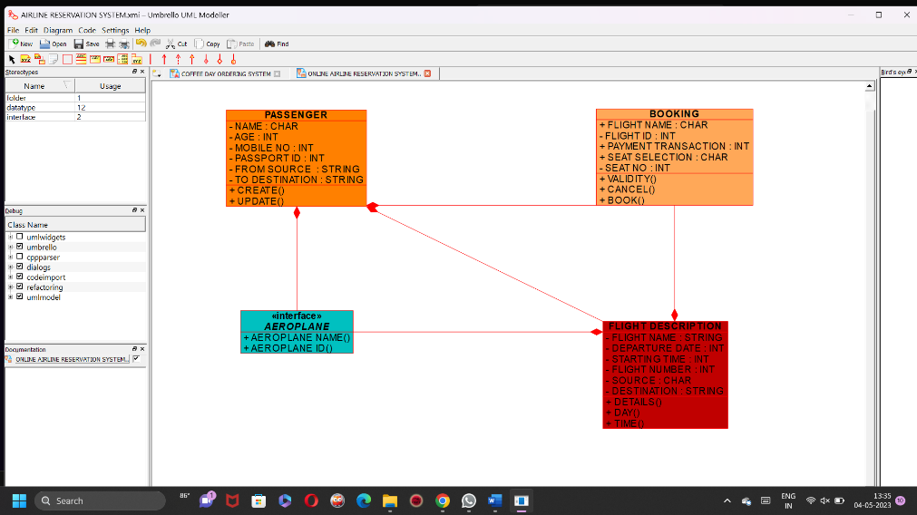

**4)aim:- To draw the UML diagram for ATM SYSTEM..**

**USE CASE DIAGRAM:-**

**Use-case diagrams describe the high-level functions and scope of a system. These diagrams also identify the interactions between the system and its actors. The use cases and actors in use-case diagrams describe what the system does and how the actors use it, but not how the system operates internally.** 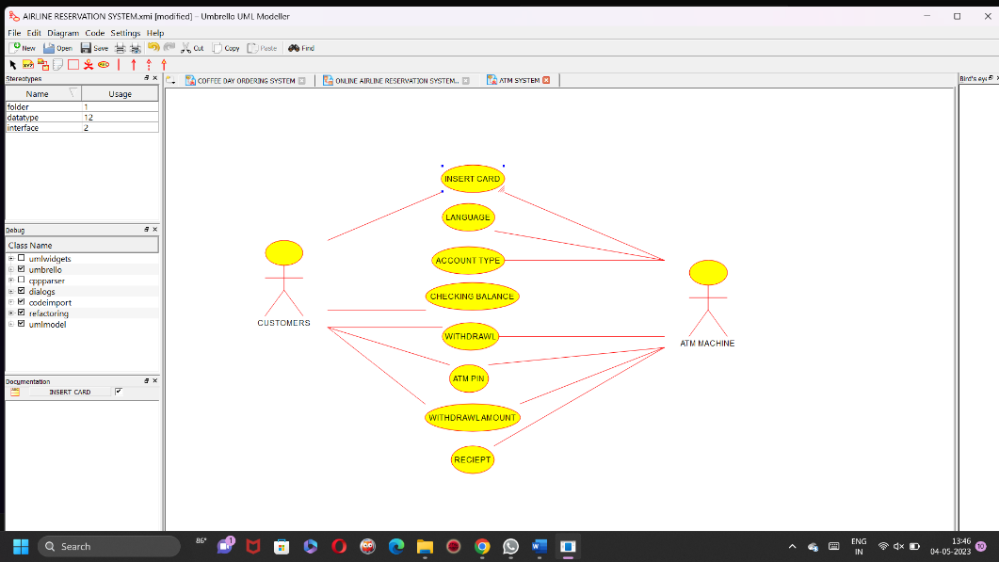

**COMPONENT DIAGRAM:-**

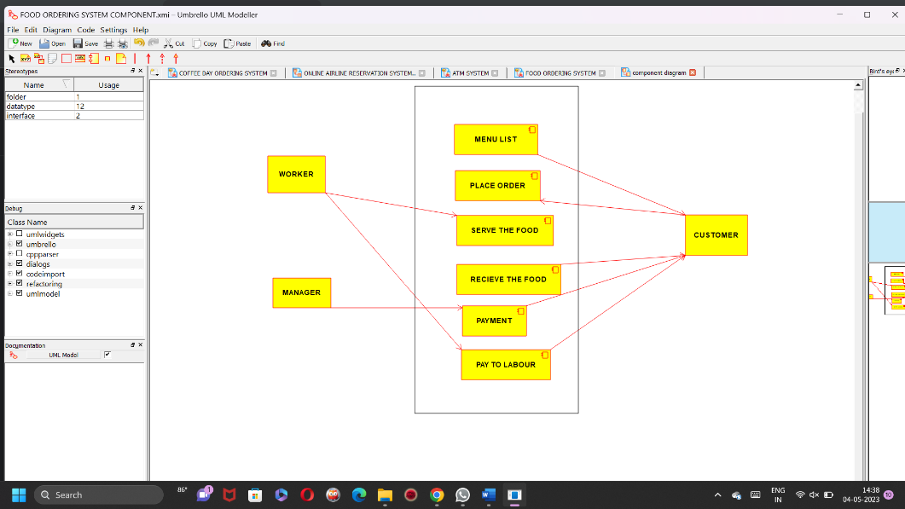

**4)aim:- To draw the UML diagram for FOOD ORDERING SYSTEM..**

**USE CASE DIAGRAM:-**

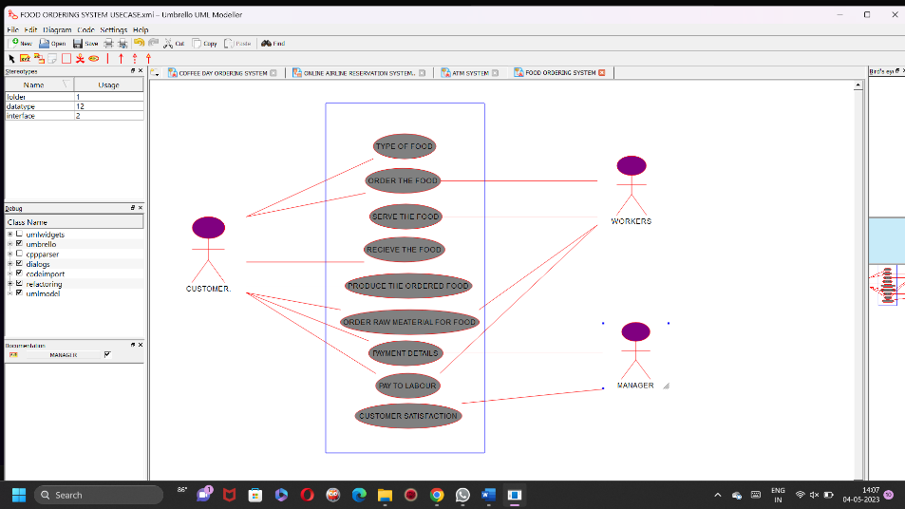

**DEPLOYMENT DIAGRAM:-**

